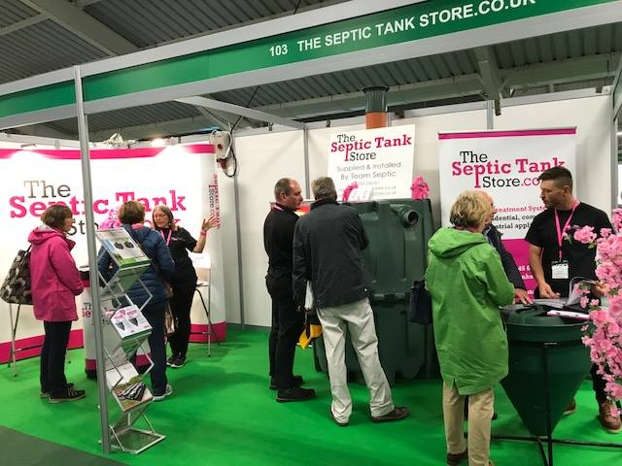 Autumn Newsletter from Team Septic

**For all of your waste water requirements please contact Team Septic on 01295 236101** [**sales@theseptictankstore.co.uk**](mailto:sales@theseptictankstore.co.uk)**, visit our website** [**www.theseptictankstore.co.uk**](http://www.theseptictankstore.co.uk)



We had a great few days meeting new and old customers at the Glamping show. We now look forward to working with you over the coming months.

We will be at the Farm Business Innovation show from the 7th – 8th of November at the NEC, Birmingham. Come along and visit us at stand 2424 where team septic will be on hand to answer any questions. Follow the below link to sign up for your free tickets to the event.

[www.farmbusinessshow.co.uk](http://www.farmbusinessshow.co.uk)



Hayden recently passed his NAPIT electrical qualification. This means that all work is kept in house.. …. well done Hayden !!!